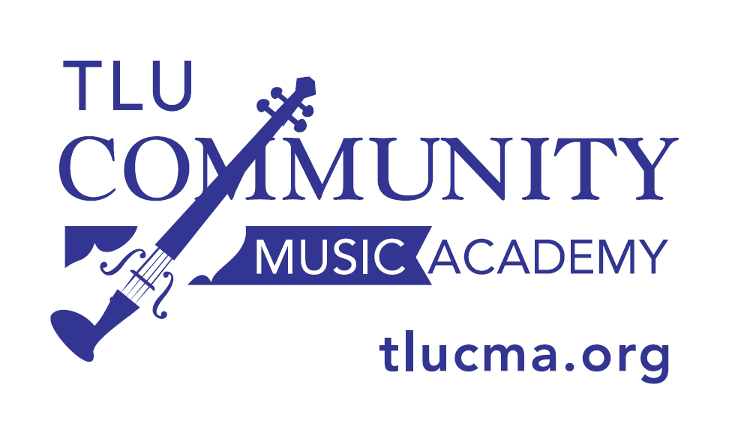

2020-2021 TLU Community Music Academy
Outreach Guitar Class Calendar
On occasion, the teacher may need to change a class day/time

Thursday Guitar Class
Dr. Chad Ibison, Instructor
chadibison@gmail.com

Online Class
Guitar Level 1: 4:30-5:25 PM
Guitar Level 2: 5:30-6:25 PM

Fall 2020: Guitar Rentals: Aug. 27
Sept. 3, 10, 17, 24
Oct. 1, 8, 22, 29
Nov. 5, 12, 19
Dec. 3

Spring 2021: Jan. 14, 21, 28
Feb. 4, 18, 25
Mar. 4, 11, 25
Apr. 8, 15, 22

