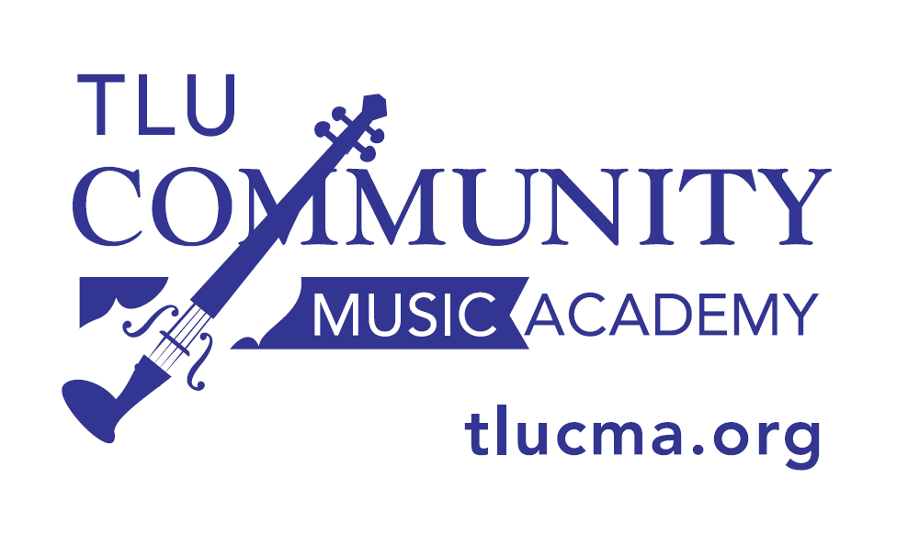

2020-2021TLU Community Music Academy
Youth Orchestras Calendar
On occasion, individual teachers may need to change a class day/time.

Beginning Orchestra A, Dr. Eric Siu, Director
Tuesdays, 4:30 – 5:15 pm in the TLU Schuech Fine Arts Center
For students who have just completed the Level 2 Outreach Program

Beginning Orchestra B, Dr. Eric Siu, Director
Mondays, 4:30 – 5:15 pm in the TLU Schuech Fine Arts Center
For students who were in Beginning Orchestra in 2019-2020

Chamber Orchestra, Dr. Eric Siu, Director
Mondays, 5:30 – 6:15 pm in the TLU Schuech Fine Arts Center

CMA Performers, Dr. Eric Siu, Director
Mondays, 6:30 – 7:15 pm in the TLU Schuech Fine Arts Center

Fall 2020

Monday Rehearsals: Tuesday Rehearsals:
Aug. 31 Sept. 1, 8, 15, 22, 29
Sept. 14, 21, 28 Oct. 6, 20, 27
Oct. 5, 19, 26 Nov. 3, 10, 17
Nov. 2, 9, 16, 30 Dec. 1
Dec. 7

Spring 2021

Monday Rehearsals: Tuesday Rehearsals:
Jan. 11, 25 Jan. 12, 19, 26
Feb. 1, 8, 22 Feb. 2, 9, 23
Mar. 1, 8, 22, 29 Mar. 2, 9, 23, 30
Apr. 5, 12, 19 Apr. 6, 13, 20

Auditions: August 24, 2020, 4 - 6 PM

Dr. Eric Siu: ericishere@gmail.com

Spring Registration: at tlucma.org Dec. 1, 2020 - Jan. 5, 2021

