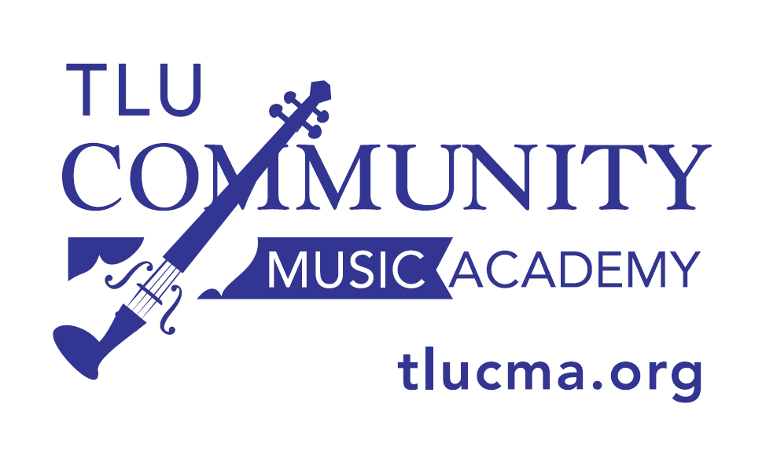

2020-2021 TLU Community Music Academy
Lindenbaum Outreach Program Calendar
On occasion, individual teachers may need to change a class day/time

Outreach Level 2 Violin Class
Dr. Eric Siu ericishere@gmail.com

Tuesdays: 5:30 - 6:15 p.m.

TLU Schuech Fine Arts Center Wupperman Little Theatre

Fall 2020: Violin Rentals: Aug. 25
Aug. 31
Sept. 14, 21, 28
Oct. 5, 19, 26
Nov. 2, 9, 16, 30
Dec. 7

Spring 2021: Jan. 11, 25
Feb. 1, 8, 22
Mar. 1, 8, 22, 29
Apr. 5, 12, 19

Outreach Level 2 Cello Class
Ms. Liz Massad massadliz1323@gmail.com

Tuesdays: 6:15 - 7:00 p.m.

TLU Schuech Fine Arts Center Band Hall

Fall 2020: Violin & Cello Rentals: Aug. 25
Sept. 1, 8, 15, 22, 29
Oct. 6, 20, 27
Nov. 3, 10, 17
Dec. 1

Spring 2021: Jan. 12, 19, 26
Feb. 2, 9, 23
Mar. 2, 9, 23, 30
Apr. 6, 13, 20

