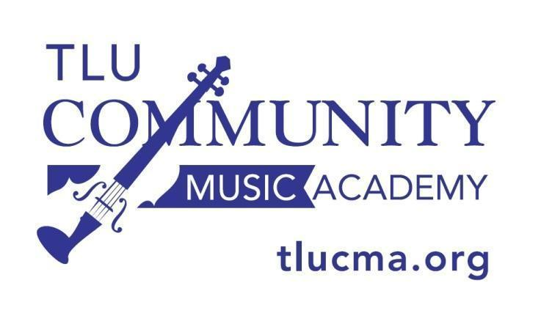

2020-2021 Youth Choirs
Schedule and Calendar

Registration
***ALL participants in Youth Choirs MUST register EVERY SEMESTER***
It’s very easy at www.tlucma.org

Fall 2020 Registration: August 1-28, 2020
Spring 2021 Registration: Dec. 1, 2020 - Jan. 5, 2021

Rehearsal Times:
All Rehearsals are at the TLU Chapel of the Abiding Presence

Intermediate and Advanced Choir: 4:45 - 5:45 pm

Fall 2020: Sept. 3, 10, 17, 24
Oct. 1, 8, 22, 29
Nov. 5, 12, 19
Dec. 3

Spring 2021: Jan. 14, 21, 28
Feb. 4, 18, 25
Mar. 4, 11, 25
Apr. 8, 15, 22

