2018-2019 - TLU’s Educator Preparation Program accreditation status – ACCREDITED by the Texas Education Agency
Texas Lutheran University
Test Pass Rates for the Completion Year 2019

Period | All | Female | Male | African American | Hispanic | Other | White
9/1/2018-8/31/2019 — PPR Exams | 100%(9) | 100%(5) | 100%(4) |  | 100%(4) |  | 100%(5)
9/1/2018-8/31/2019 — Non-PPR Exams | 100%(8) | 100%(3) | 100%(5) |  | 100%(4) |  | 100%(4)

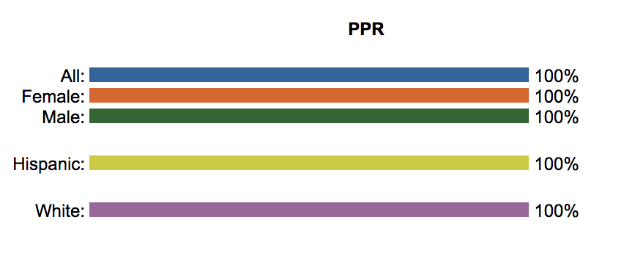
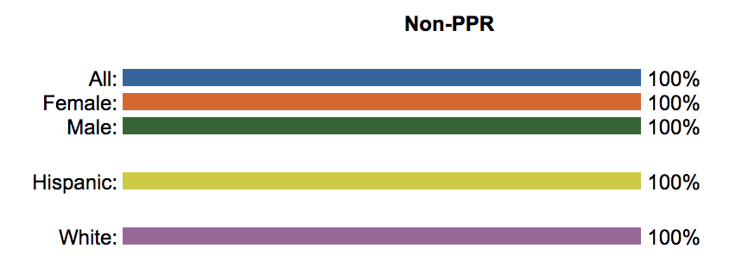

2019-2020 - TLU’s Educator Preparation Program accreditation status –
NOT RATED: DECLARED STATE of DISASTER by the Texas Education Agency
Texas Lutheran University
Test Pass Rates for the Completion Year 2020

Period | All | Female | Male | African American | Hispanic | Other | White
9/1/2019-8/31/2020 — PPR Exams | 100%(21) | 100%(15) | 100%(6) | 100%(3) | 100%(7) | 100%(1) | 100%(10)
9/1/2019-8/31/2020 — Non-PPR Exams | 95%(20) | 93%(13) | 100%(7) | 100%(2) | 100%(6) |  | 92%(12)

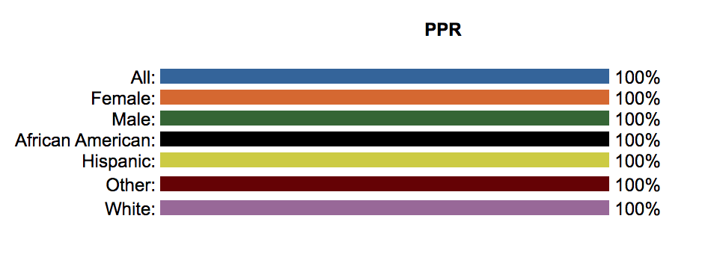
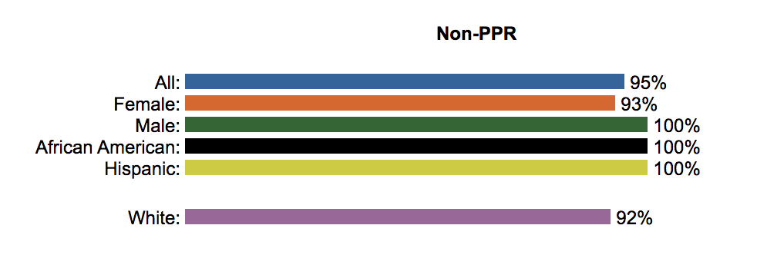

2020-2021 - TLU’s Educator Preparation Program accreditation status –
NOT RATED: DECLARED STATE of DISASTER by the Texas Education Agency

Texas Lutheran University (094501)
Test Pass Rates for the Completion Year 2021 (First 2 Attempts)

Period | All | Female | Male | African American | Hispanic | Other | White
9/1/2020-8/31/2021 — Pedagogy Tests | 98%(43) | 100%(29) | 93%(14) |  | 94%(18) |  | 100%(25)
9/1/2020-8/31/2021 — Content Pedagogy Tests | 97%(51) | 96%(34) | 100%(17) |  | 96%(19) |  | 98%(32)

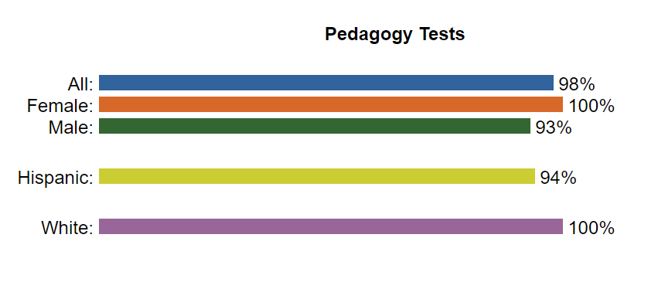
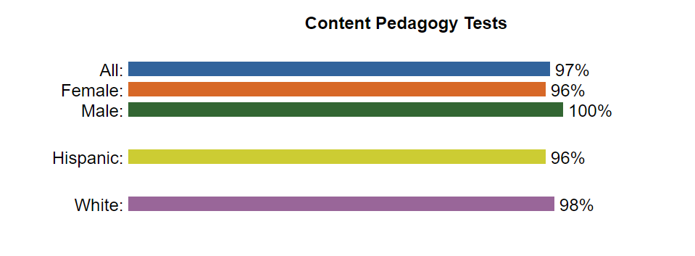

2021-2022 - TLU’s Educator Preparation Program accreditation status –
ACCREDITED – WARNED by the Texas Education Agency
Texas Lutheran University (094501)
Test Pass Rates for the Completion Year 2022 (First 2 Attempts)

Period | All | Female | Male | African American | Hispanic | Other | White
9/1/2021-8/31/2022 — Pedagogy Tests | 100%(23) | 100%(12) | 100%(11) |  | 100%(9) | 100%(1) | 100%(13)
9/1/2021-8/31/2022 — Content Pedagogy Tests | 79%(25) | 78%(17) | 82%(8) |  | 69%(12) | 100%(1) | 84%(12)
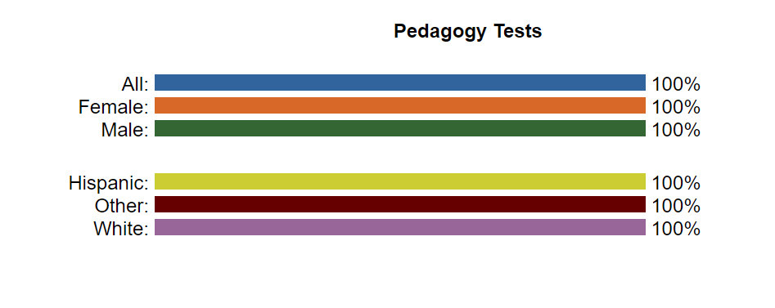
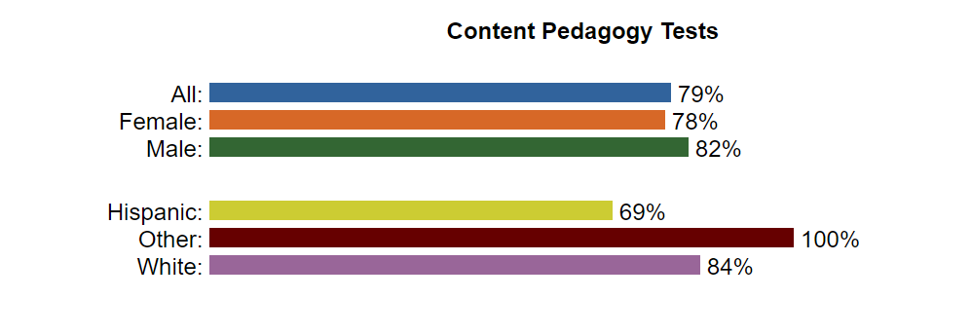

2022-2023 - TLU’s Educator Preparation Program accreditation status –
ACCREDITED by the Texas Education Agency
Texas Lutheran University (094501)
Test Pass Rates for the Completion Year 2023 (First 2 Attempts)

Period | All | Female | Male | African American | Hispanic | Other | White
9/1/2022-8/31/2023 — Pedagogy Tests | 94%(32) | 89%(19) | 100%(13) | 100%(2) | 100%(10) |  | 90%(20)
9/1/2022-8/31/2023 — Content Pedagogy Tests | 93%(32) | 92%(18) | 94%(14) | 100%(1) | 94%(12) |  | 91%(19)
