2015-2016 – TLU’s Educator Preparation Program accreditation status – ACCREDITED by the Texas Education Agency
Texas Lutheran University (094501)
Test Pass Rates for the Completion Year 2016

Period | All | Female | Male | African American | Hispanic | Other | White
9/1/2015-8/31/2016 | 98%(47) | 99%(38) | 93%(9) | 100%(2) | 100%(11) | 100%(1) | 97%(33)

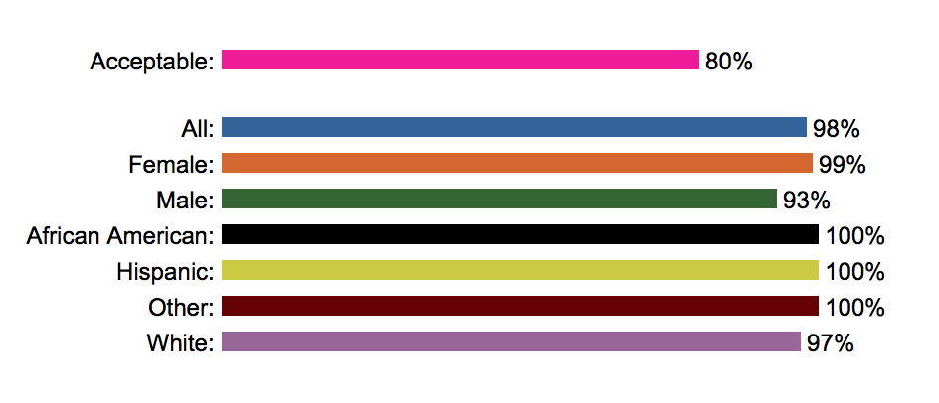

2016-2017 - TLU’s Educator Preparation Program accreditation status – ACCREDITED by the Texas Education Agency
Texas Lutheran University (094501)
Test Pass Rates for the Completion Year 2017

Period | All | Female | Male | African American | Hispanic | Other | White
9/1/2016-8/31/2017 | 98%(26) | 97%(19) | 100%(7) | 100%(1) | 100%(9) |  | 97%(16)

2017-2018 - TLU’s Educator Preparation Program accreditation status – ACCREDITED by the Texas Education Agency
Texas Lutheran University
Test Pass Rates for the Completion Year 2018

Period | All | Female | Male | African American | Hispanic | Other | White
9/1/2017-8/31/2018 — PPR Exams | 100%(2) | 100%(2) |  |  |  |  | 100%(2)

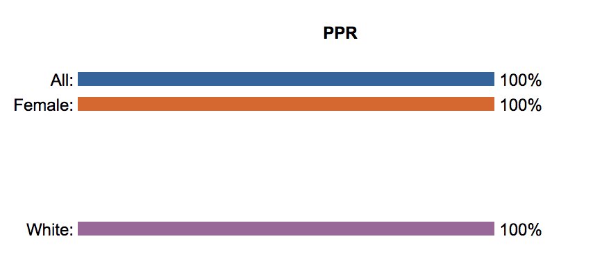
No results were reported due to a change in the how the results were reported through ECOS.

2018-2019 - TLU’s Educator Preparation Program accreditation status – ACCREDITED by the Texas Education Agency
Texas Lutheran University
Test Pass Rates for the Completion Year 2019

Period | All | Female | Male | African American | Hispanic | Other | White
9/1/2018-8/31/2019 — PPR Exams | 100%(9) | 100%(5) | 100%(4) |  | 100%(4) |  | 100%(5)
9/1/2018-8/31/2019 — Non-PPR Exams | 100%(8) | 100%(3) | 100%(5) |  | 100%(4) |  | 100%(4)

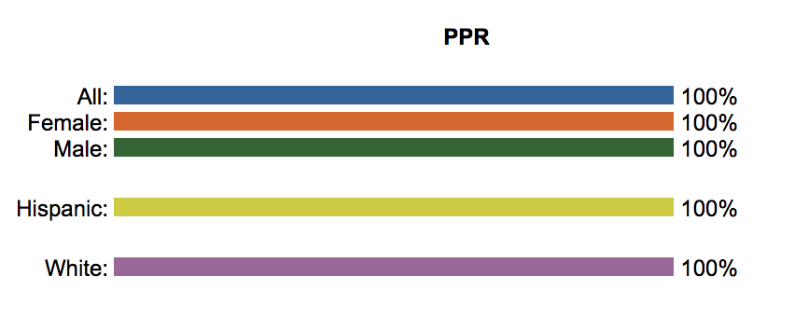
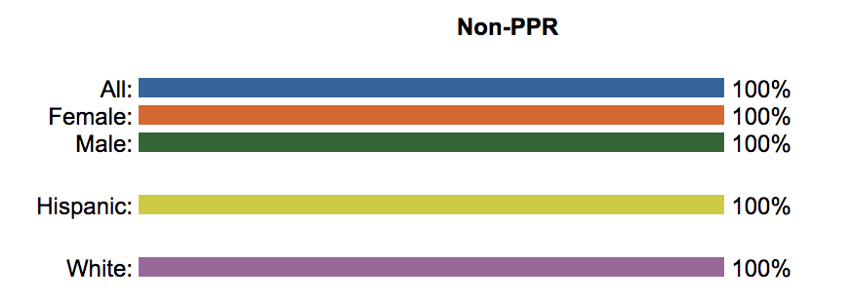

2019-2020 - TLU’s Educator Preparation Program accreditation status –
NOT RATED: DECLARED STATE of DISASTER by the Texas Education Agency
Texas Lutheran University
Test Pass Rates for the Completion Year 2020

Period | All | Female | Male | African American | Hispanic | Other | White
9/1/2019-8/31/2020 — PPR Exams | 100%(21) | 100%(15) | 100%(6) | 100%(3) | 100%(7) | 100%(1) | 100%(10)
9/1/2019-8/31/2020 — Non-PPR Exams | 95%(20) | 93%(13) | 100%(7) | 100%(2) | 100%(6) |  | 92%(12)

